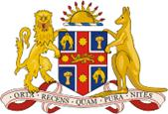
MEMORANDUM

DATE: 7 August 2021

FROM: Justice Price AO, Chief Judge

SUBJECT: COVID-19 Update Newcastle District Court

In view of the Public Health Order announced today for the Hunter region, the commencement of new jury trials in the Armidale District Court (the Court) will be temporarily suspended from 5:00pm Saturday 7 August 2021 until 12.01am Sunday 15 August 2021.

Current jury trials will continue. Other than the jury trials, there will be no personal appearances in the Court during the above period.

Practitioners should contact the Court for AVL appearance details and listing confirmation.

